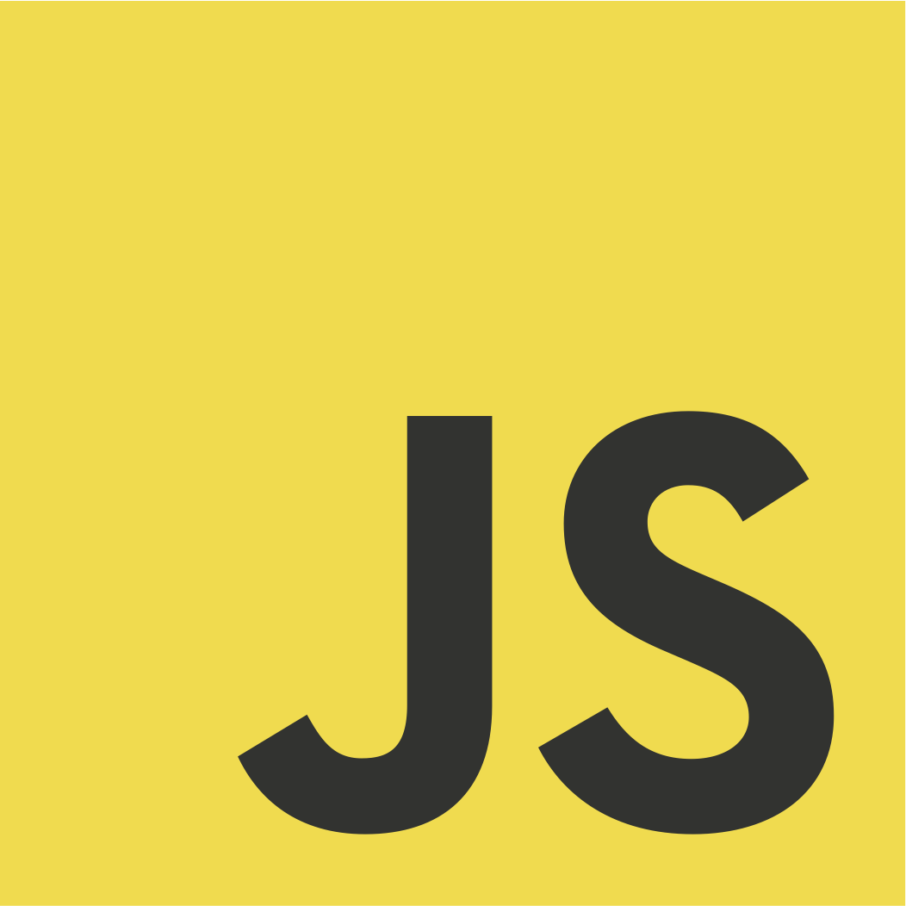 **CONTROL FLOW IN JAVA SCRIPT**

* A control flow is a statement that determines whether the other statements will be executed or not.
* It controls the flow of the execution of the program.

1. **IF STATEMENT**

* It determines whether a code should be executed based on the specified condition

If (age>=18)

Console.log (‘older person’)

1. **IF…ELSE STATEMENT**

* It tests the condition it executes, if block of condition is true otherwise else block is executed.

Let number =11;

If (number%==0)

Console.log (‘even number’)

Else

Console.log (‘odd number’)

1. **SWITCH STATEMENT**

* It is used to execute a single statement from multiple conditions.

Let marks=100;

Switch (marks) {

Case time === ‘>=100’

Console.log (Grade A’)

Break;

Case marks === ’<=80”

Console.log (‘grade B’);

Break;

Case marks ===’<=40’

Console.log (‘grade D’);

Default;

Console.log (failed the test);

Break;

**LOOPS**

* Loops are a conditional statement that repeats the given task until the given condition is met.

They are also known as iterations

**TYPES OF LOOPS**

* While
* Do While
* For Loop

1. **WHILE LOOP**

* It is used to iterate a part of the program several times.
* It repeats the process until the condition is met.

Let days = 1

While (days<6) {

Console.log (‘working day’);

Working days = days +1

1. **DO WHILE**

* It is executed at least once once because condition is checked after loop body.

Let num = 1

Do

{

Console.log (‘num’);

Num = num+1;

while (num<=10) ;}

1. **FOR LOOP**

* It is used to iterate part of the program several time.
* If the number of iterations is fixed, we use for loop mostly.
* We initialize variable, check condition and increment or decrement the value.

Let num = [10, 7, 8, 13, 20];

For (let i=0; i<num.length; i++) {

Console.log (num[i]);}